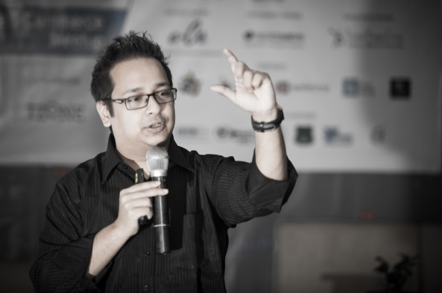

**G. Sumdany Don**

D

**on** is the Chief Inspirational Officer at Don Sumdany Facilitation & Consultancy. ([www.DonSumdany.com](http://www.donsumdany.com/)) He completed "Facilitation and Training Skills" with certified Master-trainer Sarah Krasker at the Master Trainer Institute (France) (<http://mastertrainer.ch/>), and also trained under global facilitator and brand-marketing guru Trini Amador from BHC Consulting (USA) (<http://www.bhcconsulting.com/>). For over four years, Don had the privilege to work for Philip Morris International (PMI), a Fortune 500 Company and represented one of the top 10 global brands in the world. Don trains people to communicate with customers effectively, build great teams, and inspire strong leadership among different managers. Currently he is training up 1200+ full-time employees of Grameenphone, while Chevron, Perfetti, Holcim, Envoy Group and so on are some of his regular clients.

The Class Valedictorian 2008 from ULAB, Don also conducts career build-up workshops at East West University (EWU), and the University of Liberal Arts Bangladesh (ULAB). He has conducted sessions in Dhaka University, JU, IBA JU, NSU, AIUB, BRAC, Manarat, ASA University and several others. He also offers corporate client training sessions for Bdjobs, Prothom-Alo Jobs, Business Express, and for Chartered Accountants in ICAB. He has trained over 10,000+ people so far. Don also has his own live radio show called "Donspiration" at Colours FM 101.6 and he writes for The Daily Star and has his own weekly column called "Level Up with G. Sumdany Don" published every Thursday in the SHOUT magazine section.